

Dr. Gregory, Grimes inc.
2021-04-13
Dr. Grimes
979 Sanchez Via, Leechester, AS 06679
Phone: 7802030092
Fax: 1753777021

Re: Kristina, Mckinney
PHN: 6960118370
Birthdate: 27-Sep-1937
Address: 14405 Johnson Vista, Andersenfurt, MN 12735
Patient number: 9572666848

To Whom It May Concern:

This is a medical letter to state the above patient is pregnant with expected delivery date of 29-Sep-2025. Hoping this information is satisfactory for your requirements.

Thank you.

Sincerely,
Dr. Gregory, Grimes
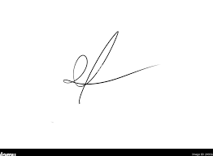
FRCS© NCMP
Clinical Assistant Professor, UBC
Department of Obstetrics and Gynecology SMH

